IDENTITY AND ACCESS MANAGEMENT

Identity and Access Management :

Identity and Access Management (IAM) is a framework of policies, processes, and technologies that manage digital identities and control user access to sensitive information and systems.

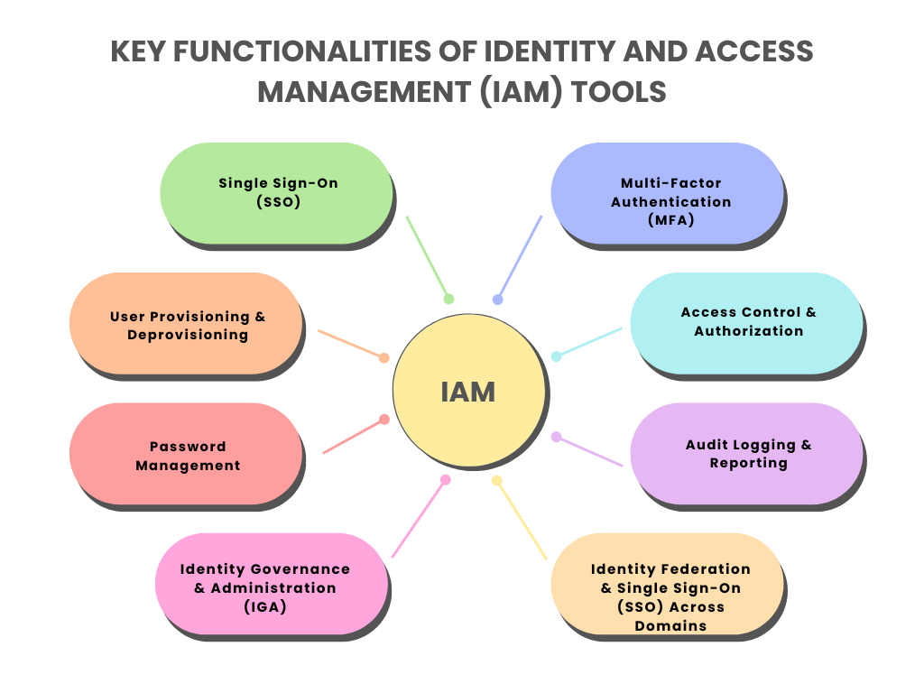

Cloud IAM in Major Providers :

|  |  |  |
| --- | --- | --- |
| Provider | IAM Service | Key Features |
| AWS | AWS IAM | * Roles , Policies, MFA * IAM Identity Center |
| AZURE | Azure AD + RBAC | * Conditional access * Entra ID (formely Azure AD) |
| Google Cloud | Google Cloud IAM | * Organization Policies * Fine-grained Permissions |
| IBM Cloud | IBM Cloud IAM | * Access Groups * Trusted Profiles |
| Oracle Cloud | OCI IAM | * Identity Domains * Federation |

Example :

Imagine you own an online store like “amazon” with:

* Customer (buy Products)
* Sellers (list products)
* Admins (manage everything)
* Delivery Team(handles orders)

Identity : “who are you?”

* Customer : Logs in via email/password or google SSO.
* Admin : Uses MFA (Password + SMS code).
* Delivery Bot : Uses API keys (machine identity).

Authentication (AuthN):

Authentication is the process of verifying a user's or device's identity to ensure they are who or what they claim to be. It is the foundational first step in any Identity and Access Management (IAM) framework and is always followed by authorization, which determines what the authenticated entity can access and do.

Example :

* Customer : Logs in via email/password or google SSO.
* Seller : Password + SMS code (higher risk, can edit product)
* Admin : Password + Biometric (highest risk, full control)

Authorization (AuthZ) :

Authorization is the process that determines what a verified user is allowed to do or access within a system. It is the second step in the identity and access management (IAM) process, occurring only after a user's identity has been confirmed through authentication.

Example :

|  |  |  |
| --- | --- | --- |
| ROLE | PERMISSIONS | EXAMPLE |
| Customer | * View products * Buy * Review | Can’t delete products |
| Seller | * Add/Edit product * View sales | Can’t see other seller’s data |
| Admin | * Delete users * Manage payments and logs | Full access |
| Delivery | * View orders, update status | Can’t see credit cards |